**­­­**

**this is the company that puts mascara on lashes and food on tables. That fights wrinkles with one hand and Breast Cancer with the other. That knows the value of a perfect lip, but still opens its mouth and speaks out against Domestic Violence and for women’s financial independence. This is the company that not only brings beauty to doors, but also opens them. The company that supports more than 6 million Representatives in over 100 countries. This is Avon. This is the company that for more than 125 years has stood for beauty, innovation, optimism and above all  
for women**.

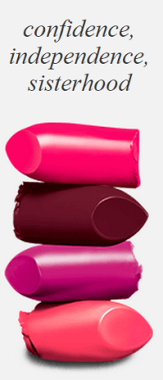

Why Avon?

1. Cutting edge skincare line
2. 125 years of history and name recognition.
3. Low startup fee $15
4. Free website & online store
5. Set your own hours
6. No inventory & no minimums
7. If it’s not for you, just pay your remaining balance and stop!
8. Earn by building a team.
9. Recognition and bonuses!
10. Be your own boss! Start today!!

­­[**www.AvonbyRhonda.biz**](http://www.AvonbyRhonda.biz) **our Team Website**

**Independent Avon Representative, Team Leader, Honor Society, Rhonda Velasquez**

**Shop online @ http://youravon.com/rhondavelasquez**

Call now at 559-709-9983 and join an active Avon team! Or get started now by going to [www.AvonbyRhonda.biz](http://www.AvonbyRhonda.biz) and click on “Get Started” pay your $15 get your kit in 4 days!

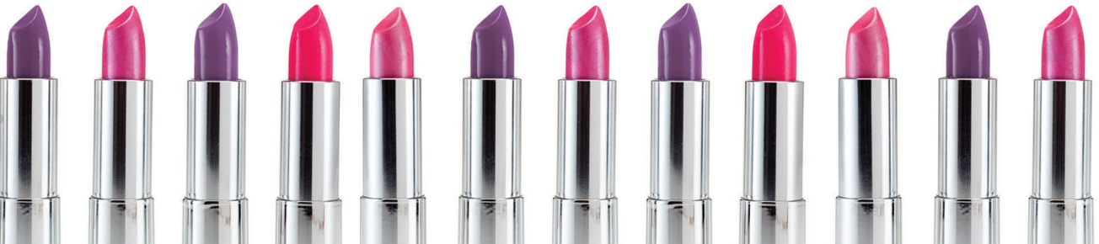 **www.AvonbyRhonda.biz**

#### *How much can I make selling Avon?*

#### Your earnings match your efforts, and your passion. You have the opportunity to grow your earnings as you grow your sales. Build on your success by inviting people into the Avon business and earn on recruiting efforts and team sales. Your success is unlimited. http://www.teammoneymakers.com/NEW%20EARNINGS%20C-8%202014.JPG

#### *How do I place orders and get paid?*

When selling face-to-face, simply collect payment with your Customer's order, then place the order via your New Representative portal online. You will earn the difference between the catalog price and the wholesale price. Products will be sent directly to you to then deliver to your Customers.

For your Customers ordering online, through direct delivery, you’ll receive payment and earnings through direct deposit – that’s it!

*The Sisterhood of Avon!*

**Sixteen Avon Representatives were recently selected to be part of a new campaign featured in the Avon Brochures. They are our models and our role models.   
  
Being an Avon Representative isn’t just about selling beauty products. It’s about a community of passionate women. It’s about being empowered and independent. When you join Avon as a Representative, you’re not just joining a company; you’re joining a sisterhood of 6 million women from around the world.  
  
A career as an Avon Representative provides flexibility. This is why moms like Lisa Monoson and Shaundre Bryson love Avon. They make their own hours so they can spend as much time with their families as possible.  
  
Avon also helps to empower women by helping them reach financial independence. Representatives like Orenthia Ricketts have been able to support themselves and their families by selling beauty products that they love.**

*Sign up for just $15, start your business today!*

Our starter kit gives you all the essentials to get you up and running. Register on our exclusive site for Representatives, your go-to resource for info, tools, training and ordering. And you’ll be paired with an Avon sales leader to support and help you every step of the way.

*Share your Avon catalogs (brochures) everywhere you go*

And put your free Avon eStore to work so customers can shop with you online 24/7. Easy social media tools and mobile apps help you promote online in a flash.  
  
And every two weeks a new campaign gives you a new brochure full of must-have products and offers to sell with.

Grow your earnings, perks and rewards when you help others start their own Avon business and build a team. Earn $35 for every recruit who places a $100 first order. You can earn a lot by building a team, for example: with 100 reps on your team and $9,000 in team sales you can earn approximately $600 a month. Imagine the possibilities! Invite a friend to to sell with you and share the fun and empowerment of selling Avon.